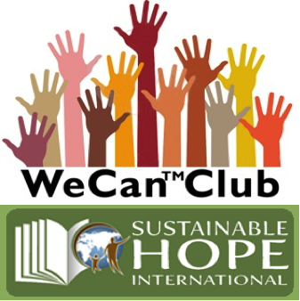
Sustainable Hope International
2815 Hickory Ridge
Independence MO 64057 USA

Photo Release Form
Permission to Photograph

I grant to sustainable Hope International, its representatives, and employees, the right to take photographs of me and my property in connection with activities, events, programs and meetings associated with We CanTM English Clubs, We CanTM Advisor Training, and We CanTM Youth Leadership Camps.

I authorize Sustainable Hope International, its assigns and transfers, to copyright, use, and publish the same in print and/or electronically.

I agree that Sustainable Hope International may use such photographs of me with or without my name and for any lawful purpose, including such purposes as marketing, publicity, fundraising, illustrations and web content.

I have read and understand the above.

Name: _________________________________________

Signature: _________________________________________

Organization: _________________________________________

Location: _________________________________________

Date: _________________________________________

Signature of parent/guardian of Teacher/Administrator if applicable:

_________________________________________

