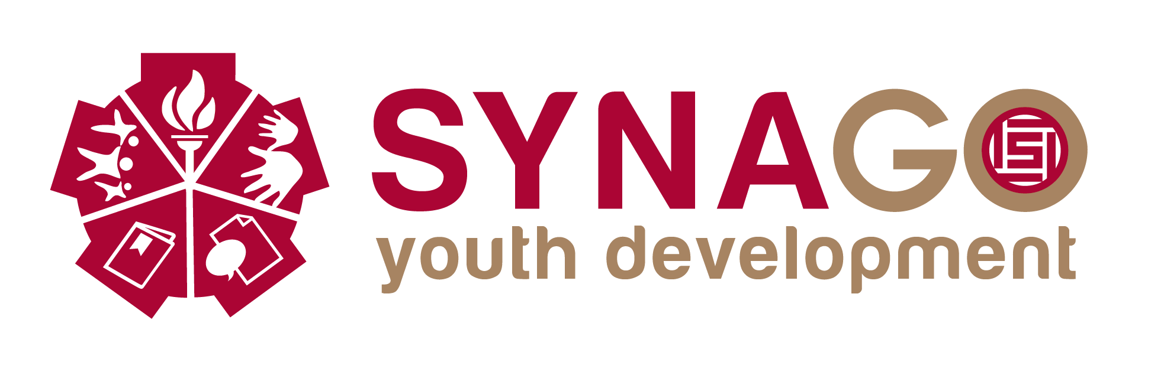
We CanTM Club Curriculum Scope and Sequence
based on Synago Youth Development Model for Global Leadership
Sustainable Hope Thailand Foundation 2014

Skill Focus | Year 1 | Year 2 | Year 3
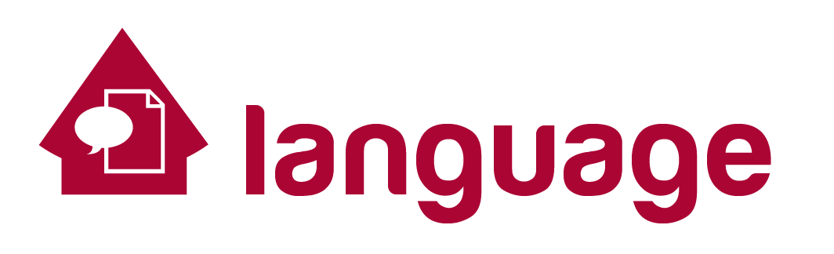
Learning Language
English As a Second Language | Learning about Self | Learning about Relationships | Leaning about Global Issues
 | Basic Grammar | Comprehension & Understanding | Comprehension & Understanding
 | Conversational English | Conversational English | Conversational English
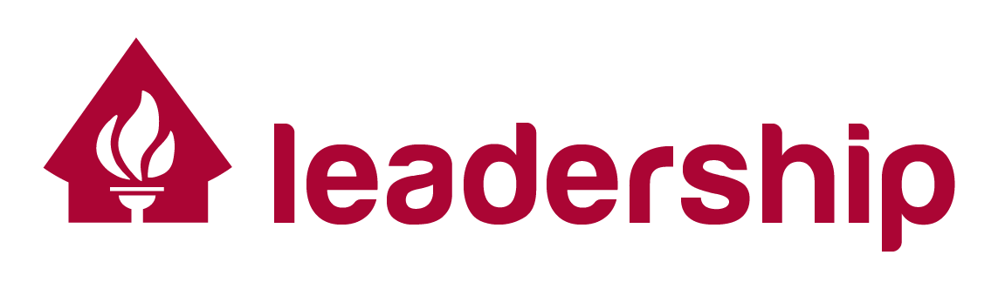
Becoming A Leader
Parliamentary Skills in conducting meetings | How to have a Meeting,  How to make a motion,  How to end a meeting | How to ask for information,  How to make amendments  How to postpone action | How to call a Point of Order,  How to delay an action  How to call for the vote.
Basic Leadership Skills | Communicating | Working in Teams  Cooperation and collaboration | Taking action, Pursuing Goals
 | Identifying/Prioritizing Problems | Finding Solutions and Making Decisions | Public Speaking:  Learning to Debate
 | Leading meetings and understanding leadership roles | Introducing others, Interviewing, and Presenting | Motivational Leadership Principles
 | Record Keeping and Reporting | Accountability and transparency | Global Leadership Skills
 | Organizing and delegating | Setting priorities, information gathering and goal setting
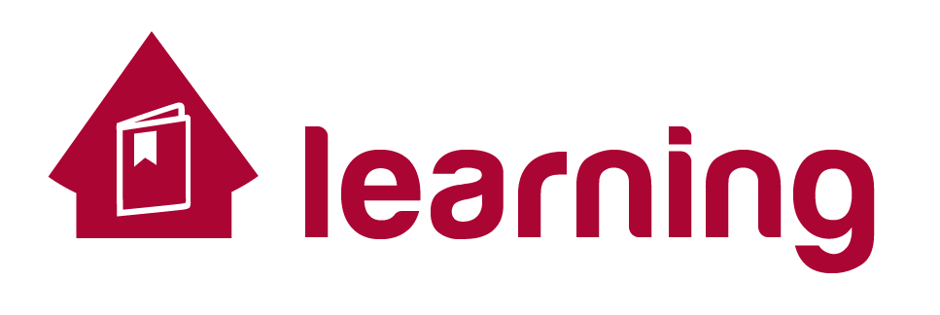
Understanding Myself
Self-knowledge | Who Am I? | Me in Relationship | Empowered Girls  Gender Roles, statistics, careers
 | Learning about what I value | Discovering my interests | Empowered Boys
Critical Thinking Skills | Making good decisions | Improving my actions | Acting to help others
 | Discovering my Strengths | Building on my Strengths | Applying my Strengths
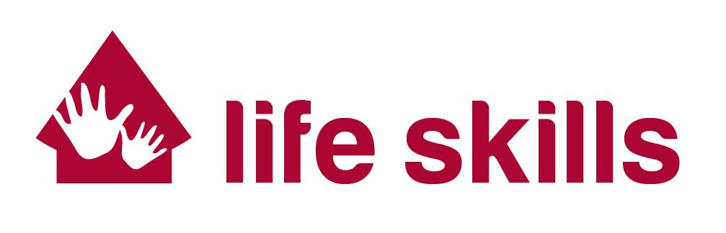
Caring for Myself
Health | Resisting Drug Use: Making Healthy Choices | Personal Hygiene, Cleanliness, Disease Prevention, HIV/Aids | Sex Education, ethics, and gender issues
 | Nutrition | Taking Care of Yourself: Basic First Aid | Childcare, Parenting
Finance | Wants and Needs:  Making Wise Choices | Life Expenses: Housing, food, transportation, healthcare, | Economy and systems: employment potential, (negatives: child labor/brides, prostitution)
 | Goals, Planning and Budgeting | Understanding banking, economic issues, life planning | Assessing resources: micro-loans, savings accounts, investing
Vocation | Commitment to Lifelong Learning | Exploring livelihood, career, job skills, education | Job seeking skills, interviewing, creating resumes,
 | Social Skills and Codes of Conduct | Work ethic, workplace manners, labor laws | Local and World marketplace, entrepreneurial spirit, starting a business
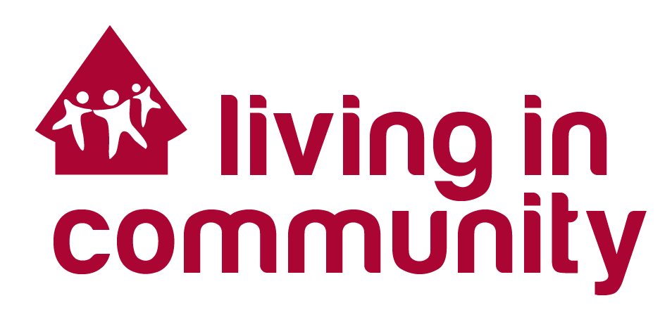
Community Service
Citizenship and Culture | Belonging to Communities | Community Service: Individual Volunteering | Laws and legal systems
 |  | Ecology and environment | Local and Global Institutions for Solving Problems: Government, NGO, Business, Social
 | Team Service Learning Macro-Project | Learning from Community Leaders  (Educational, business, sports, medical, legal, governmental)  Interviewing Community Leaders | Mentoring  Volunteering/internships with community/business leaders  shadowing for summer project on career interests, educational opportunities
 |  | Team Service Learning Micro-Project | Exploring and Understanding how we encounter other cultures
Sustainable Hope International works with poor, underprivileged, neglected, at-risk and orphaned youth by providing leadership training and scholarships for advanced education. SHI works in partnership with the Thailand Ministry of Education in providing leadership training programs in government sponsored Welfare Schools and orphanages.

